SOIL 4234 Field Soil Sampling

Field Soil Sampling, Soil Testing, and Making Fertilizer Recommendations

Objective: Experience soil sampling and become acquainted with field and laboratory variability in relation to using soil testing as a guide to nutrient management.

Materials: Field, geo-referenced points, soil probes, plastic buckets and sample bags, analytical lab.

Procedures: A 6 acre field under management of the OSU Horticulture Department will be sampled. The field is located slightly west of Western Road on the north side of McElroy Street, Stillwater, OK (Figure 1.). Four different samplings will be used to demonstrate different approaches to identifying nutrient needs of the field, field variability, and lab testing variability.
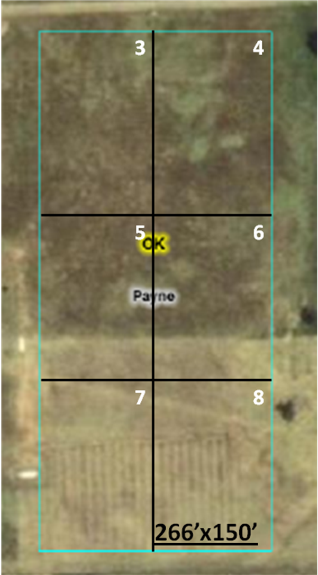
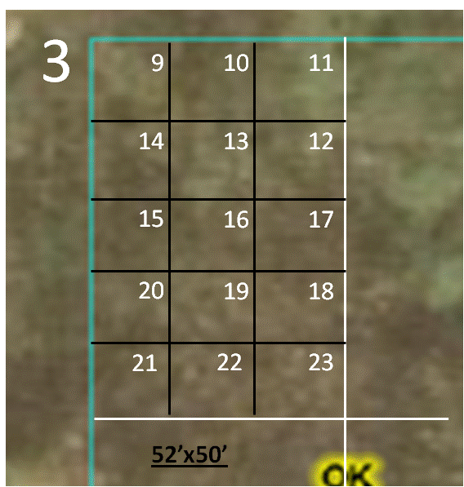

North

Figure 2

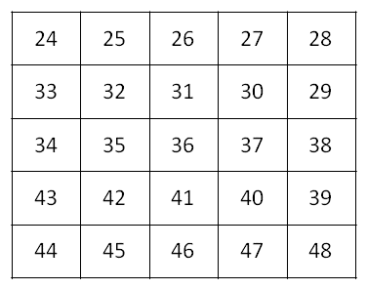

Figure 3

Figure 1

Figure 1. Aerial view and geo-referenced points for grid sampling 6-acre field.
Figure 2. Expanded view of cell-3 shows “high resolution” cell designations.
Figure 3. Expanded view of cell 15 shows “Ultra high resolution” cell designations.

Lab One six groups of 3 individuals.
Lab Two 4 groups of 2 to 3 individuals.

- Sampling
  - Random sampling of the entire field. (Repeated by lab Section 1 and lab Section 2). Pair 1. Collect a composite random sampling of the entire 26.9 acre area by obtaining 25 cores of soil from a 0-6” depth, mixing the cores in a plastic bucket and filling two soil sample bags from the composite mixture.
  - Grid-cell sampling.
    - Cell assignments.
      - Lab Section 1. Lab groups will sample the numbered cells according to the following assignments:

Group/pair | Cell
1 | 1, 11, 12, 35
2 | 3, 13, 24, 25,
3 | 4, 14, 26, 27,
4 | 5, 15, 28, 29,
5 | 6, 16, 30, 31,
6 | 9, 10, 32, 33, 34
      - Lab Section 2. Lab groups will sample the numbered cells according to the following assignments:

Group/pair | Cells
1 | 2, 19, 20, 42
2 | 7, 21, 36, 37
3 | 8, 22, 23, 38,
4 | 17, 18, 39, 40, 41

    - Sampling procedure.
Area-Composite Sample. Obtain 15 cores, 0-6” deep, at random from an area half way between the reference flag (cell center) and the center flags for bordering cells. If the cell is along the field border, sample to the field border. Label the sample with the cell number
  - High resolution. Cell 8 (Figure 1.) has been separated into 15 smaller cells for sampling at a higher resolution (0.06 acre). As groups complete sampling the 1-acre cells, they will sample these smaller cells. A composite sample will be obtained from each cell. Label high resolution samples with the cell number and the letters “HR”
    - Lab Section 1 will sample sub-cells 9-16
    - Lab Section 2 will sample sub-cells 17-23.
  - Ultra High Resolution. Cell 15 of the High Resolution cells will be further subdivided (stakes and strings) into 25 smaller cells. These cells will be approximately 10 feet x 10 feet in size. The numbering scheme, and sampling assignment per group, will be similar to that for the group of High Resolution cells (Figure 1).
    - Lab Section 1 will sample sub-cells 24-35
    - Lab Section 2 will sample sub-cells 36-42.

  - Use the Table on the next page to guide you in putting the correct sample in the correct bag. Bags will be pre-labeled and passed out prior to the field exercise. If your group finishes and others are still collecting samples please go to their aid to speed up the lab.

SWFAL | Lab | Section | Cell | Description
Lab # | Section | Group | #
31 | 1 | 1 | 1 | Composite #1
32 | 1 | 1 | 1 | Composite #2
33 | 1 | 1 | 11 | .06 acre "High"
34 | 1 | 1 | 12 | .06 acre "High"
35 | 1 | 1 | 35 | .002 ac "Ultra"
36 | 1 | 2 | 3 | 1 acre
37 | 1 | 2 | 13 | .06 acre "High"
38 | 1 | 2 | 24 | .002 ac "Ultra"
39 | 1 | 2 | 25 | .002 ac "Ultra"
40 | 1 | 3 | 4 | 1 acre
41 | 1 | 3 | 14 | .06 acre "High"
42 | 1 | 3 | 26 | .002 ac "Ultra"
43 | 1 | 3 | 27 | .002 ac "Ultra"
44 | 1 | 4 | 5 | 1 acre
45 | 1 | 4 | 15 | .06 acre "High"
46 | 1 | 4 | 28 | .002 ac "Ultra"
47 | 1 | 4 | 29 | .002 ac "Ultra"
48 | 1 | 5 | 6 | 1 acre
49 | 1 | 5 | 16 | .06 acre "High"
50 | 1 | 5 | 30 | .002 ac "Ultra"
51 | 1 | 5 | 31 | .002 ac "Ultra"
52 | 1 | 6 | 9 | .06 acre "High"
53 | 1 | 6 | 10 | .06 acre "High"
54 | 1 | 6 | 32 | .002 ac "Ultra"
55 | 1 | 6 | 33 | .002 ac "Ultra"
56 | 1 | 6 | 34 | .002 ac "Ultra"
57 | 2 | 1 | 2 | Composite #1
58 | 2 | 1 | 2 | Composite #2
59 | 2 | 1 | 19 | .06 acre "High"
60 | 2 | 1 | 20 | .06 acre "High"
61 | 2 | 1 | 42 | .002 ac "Ultra"
62 | 2 | 2 | 7 | 1 acre
63 | 2 | 2 | 21 | .06 acre "High"
64 | 2 | 2 | 36 | .002 ac "Ultra"
65 | 2 | 2 | 37 | .002 ac "Ultra"
66 | 2 | 3 | 8 | 1 acre
67 | 2 | 3 | 22 | .06 acre "High"
68 | 2 | 3 | 23 | .06 acre "High"
69 | 2 | 3 | 38 | .002 ac "Ultra"
70 | 2 | 4 | 17 | .06 acre "High"
71 | 2 | 4 | 18 | .06 acre "High"
72 | 2 | 4 | 39 | .002 ac "Ultra"
73 | 2 | 4 | 40 | .002 ac "Ultra"
74 | 2 | 4 | 41 | .002 ac "Ultra"
Results and Report:

SOIL TEST RESULTS

  - Random sampling of the entire field.

Results of entire field random sampling, and splitting the random sample into two separate samples are given in Table 1.

Table 1. Soil test results* for composite samples from random sampling of entire field.
Sample | pH | BI | ECCE | NO₃-N | N Req. | P | P₂O₅ Req. | K | K₂O Req.
Pair 1-1
Pair 1-2
Pair 1- Ave.
Pair 2-1
Pair 2-2
Pair 2- Ave.
Difference, Pair 1 and Pair 2
*Units are lb per acre for N and ton per acre for ECCE lime. Other values are indexes.

  - Grid-cell sampling.

Results of sampling 6 individual cells, after obtaining a composite of 15 cores randomly taken from the entire area of each cell, are given in Table 2.

Table 2. Soil test results* for composite samples of each 1-acre cell
Cell | pH | BI | ECCE | NO₃-N | N Req. | P | P₂O₅ Req. | K | K₂O Req.
3
4
5
6
7
8
Ave.
Stdev
CV
*Soil test units are lb/acre for N and indexes for other measures. Requirements are ton per acre for ECCE lime and lb/acre for N, P₂O₅, and K₂O.
  - High resolution.

Results of sampling 15 individual cells within the 1-acre cell number 3, are given in Table 3.

Table 3. Soil test results* for composite samples from each of 25 cells within a 1-acre cell.
Cell | pH | B.I. | ECCE | N | N Req. | P | P₂O₅ Req. | K | K₂O Req.
9
10
11
12
13
14
15
16
17
18
19
20
21
22
23
Ave.
Stdev
CV
*Soil test units are lb/acre for N and indexes for other measures. Requirements are ton per acre for ECCE lime and lb/acre for N, P₂O₅, and K₂O.

Results of sampling 15 individual cells within the 1/15th acre cell number 16, are given in Table 4.

Table 4. Soil test results* for composite samples from each of 25 cells within a 1/15th acre cell.
Cell | pH | B.I. | ECCE | N | N Req. | P | P₂O₅ Req. | K | K₂O Req.
24
25
26
27
28
29
30
31
32
33
34
35
36
37
38
39
40
41
Ave.
Stdev
CV

CALCULATIONS:

- Random sampling of the entire field.
  - Calculate the average soil test values (complete Table 1) for each pair’s composite sample. This is the average for the two bags of soil that were filled from a single bucket containing at least 15 randomly taken cores.

  - Using the average values you calculated, explain whether there is there more error in the lab (difference between two samples from the same bucket) or among people taking the sample (difference between average results for pair 1 and pair 2)?

  - Would lime and nutrient inputs identified by the soil tests be markedly different using the samples from pair 1 compared to pair 2?

- Random sampling 1-acre cells.
a. Complete Table 2 by identifying and recording the amounts of lime, N, P₂O₅ and K₂O required to support production of wheat grain, in rotation for a 50 bushel/acre yield goal. Use the web site below to find the lime and nutrient requirements.

http://www.soiltesting.okstate.edu/Interpretation.htm

b. Add the amounts of lime, N, P₂O₅ and K₂O required for each cell and record the totals below.

lime ________ tons N ________lb. P₂O₅ ______ lb. K₂O______ lb.

c. Identify the per-acre requirements for the entire field using the average soil test values for the 6 cells and record those values below.

lime ________ tons/acre N ________lb/acre P₂O₅ ______ lb/acre K₂O______ lb/acre

Now multiply these values times 6 to obtain the total field requirement and compare these values to those calculated by totaling requirements for each cell (part 3).

lime ________ tons N ________lb. P₂O₅ ______ lb. K₂O______ lb.

d. Calculate the largest differences between a single rate for the entire field based on average soil test values, and the amount applied to an individual cell based on soil test values for that cell, for each input. Record the amount and cell below.

lime ________ tons (cell_____) N ________lb. (cell_____) P₂O₅ ______ lb. (cell_____)

K₂O______ lb. (cell_____)

e. If the cost of soil testing was not a factor, explain the benefit of treating each cell individually compared to applying an average rate of inputs for the entire field. Consider yield differences and fertilizer and lime costs in your explanation.

- High resolution.
  - Complete Table 3 by identifying and recording the amounts of lime, N, P₂O₅ and K₂O required to support production of wheat grain, in rotation for a 50 bushel/acre yield goal.
  - Compared to a single rate application based on the results for cell 3 in Table 2., describe the benefit of high-resolution sampling (reference specific data to support your answer)?

- Looking at the statistics reported in Tables 2, 3, and 4 at what scale would you apply N, P, K, and lime. ( make a decision on each input separately.

